BERGH APTON HORSE SHOW 2022 EQUESTRIAN EVENTS REGISTRATION FORM – Please complete all sections in capitals and return:-

By email to: ba_horseshow@outlook.com - registration will be accepted and confirmed when payment has been received into the Show Bank Account.
Or by post with a cheque to the Admin. address: c/o Kents Cottage, Threadneedle St., Bergh Apton, NR15 1BJ
ADVANCE BOOKING SPEEDS THINGS ALONG ON THE DAY, SAVES QUEUING AND SAVES YOU MONEY

NAME |  |  | 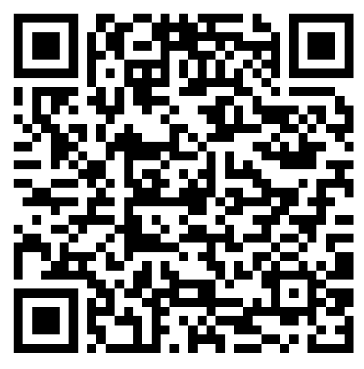
ADDRESS

TELEPHONE
EMAIL
EMERGENCY CONTACT DETAILS
I have read and agree to abide by the rules set out on page 5 of the Show Schedule |  | Name: ………………………………………………………  Date: ……………………………………………………..

ENTRY FEES: £8.00 per class for Advance* payment and registration - *RECEIVED BT 21ST JULY. No Dressage entries accepted after 21st July
Additional £2.00 per class for On-The-Day entries and payments.
Fun Classes: £5.00, no extra fees for late entries
Online payment: https://givealittle.co/campaigns/b749ea69-ff46-4da6-bcfd-6244ad138c72 or via the QR code above.
Cheques to be made payable to Bergh Apton PCC

Official use only:  Competitor No | Class No. | Class Name | Rider/Handler Name | Age if under 18 | Horse/Pony Name | Entry fee
 |  |  |  |  | TOTAL

